**SAFIA ABDULLA ABD AL-RAZZAQ**

House NO: 108, Road NO: 66 Block NO: 360

Zinj, Manama, Bahrain  
Mobile: +973 35126081/ +973 39408385

Email: [Maryam-al-7lwa@hotmail.com](mailto:Maryam-al-7lwa@hotmail.com)

[safia08@outlook.com](mailto:safia08@outlook.com)

***Personal Details***

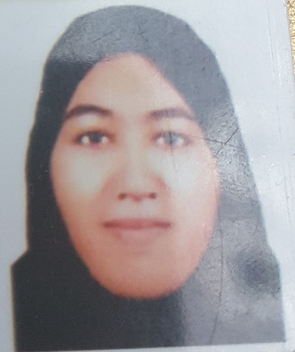

Nationality : Bahraini

CPR Number : 890606510

Date of Birth : 23 Jun 1989

Place of Birth : Manama

Material Status : Single

Young girl has several skills in optimization, and analysis. Reliable, ambitious, self, seeking for a good opportunity in a reputable company, where skills could be further developed and applied. Systematic and confident team member as demonstrated by several successful group projects at University. Enthusiastic, organized, planned worker who takes a logical approach to challenges. Gained a balance of practical and technical academic qualities as well as get a brief knowledge about computer, management and communication.

***Education***

* Graduated from Hoora Secondary School for girls in 2007.

***Professional Experience******s***

* Casher at bookshop in 2007.
* Participating in several competitions, conferences, and seminars.

***Languages***

* English spoken & written.
* Arabic spoken & written.

***Additional Skills***

* Microsoft office applications.
* Teaching.
* Accounting and Insurance.
* Maintain good relationships with Colleagues and Superiors.
* Good in Project Management.
* Problem solving and Critical Thinking.
* Work under Pressure and in Severe Environment.
* Fast learning.
* Leadership.
* Research and strategic planning.

***Hobbies and Interests***

|  |
| --- |
| * Discovering new Things. * Reading. * Voluntary work for Community Service. * Cooking. * Drawing. * Communications with Others. |

***I would be pleased to discuss my C.V. with you in more details at an interview. In the meantime, please do not hesitate to contact me if you required further information.***